April 16, 2020

MISS UTILITY/DISTRICT ONE CALL ANNOUNCES,
NEW ENHANCEMENTS TO THE OUTBOUND TICKET AND TICKET CHECK FUNCTIONS FOR DISCREPANCY/DISPUTE NOTICES
When processing your excavation ticket, you will notice a new field has been added; TRENCHLESS. A drop-down box is provided for easy selection of, YES, NO or UNKNOWN. All previously processed tickets prior to April 16, 2020 were auto-filled with UNKNOWN.
The TRENCHLESS field information does not carry over to updated tickets; please select the option that best describes your work for the updated ticket during its validity period based on State/District law. If you have questions, please call our Help Desk at 410-712-0556 during business hours for assistance.
TICKET CHECK NEW ENHANCEMENT TO THE DISCREPANCY & DISPUTE NOTICE.
All Maryland owner-members must comply to Title 12-126(c) law regarding reporting to the underground facilities information exchange system, known as Ticket Check.
The District of Columbia refers to locate positive response duties in section 34-2704 (c) and (e). Some members in the District use DC Ticket Check as their method of positive response.
In all cases, no excavation should begin without having a response from each notified owner-member.
The below information is for those members/locators using the Ticket Check system.
Excavators can better communicate their ticket’s locate matters with the recent change to the Discrepancy/Dispute function by adding both notes and pictures/attachments when these Ticket Check notices are selected on the Search & Status view of the ticket and successfully processed.
Here are the main points;
- Search & Status is where the excavator starts the process of notifying member locator(s) of a locate Discrepancy or a code 5 Dispute issue at; www.missutility.net.
- The process is two parts;
  - Clicking the Discrepancy/Dispute button on the Search and Status ticket view of a valid ticket, and
  - Finishing the process using your email browser.
  - While completing the email process, excavators can add notes and pictures/attachments.
  - The previous Ticket Check code will be UNLOCKED to allow the locator to restatus the ticket within two days of receipt of the Discrepancy/Dispute notice.
- Members will receive a copy of the Ticket Check notice displaying the header; Discrepancy or Dispute.
- The excavator notes will be posted on the transmitted ticket to the affected members/locators.
- The excavator attachments will be provided on the transmitted ticket to the affected members/locators.
- Search & Status will display ‘View Attachments’ on the ticket view and the excavator’s notes will appear in the ‘Status’ section of ‘MEMBERS NOTIFIED’.
- Members/Locators who do not restatus the unlocked Discrepancy/Dispute ticket will receive a No Response from the call center each day until the ticket is restatused or the ticket expires.

Below are instructions for successfully processing a Discrepancy/Dispute Ticket Check notice.

Please do not begin excavation or demolition until all notified owner-members have responded to your ticket number. Ticket Check codes and rules for Maryland and the District are available at, www.missutility.net under the state or district label.

USE SEARCH & STATUS TO SUBMIT A TICKET CHECK, DISCREPANCY OR DISPUTE

Once a ticket has been processed and the locator has placed a Ticket Check status on the ticket, the excavator may process a discrepancy ticket using Search & Status if they find evidence of unmarked utilities based on the Extent of Work provided on their ticket.
Search & Status can be accessed at, www.missutility.net Click your tickets’ service area; Maryland (selecting either west or east of the Chesapeake Bay) or District of Columbia.
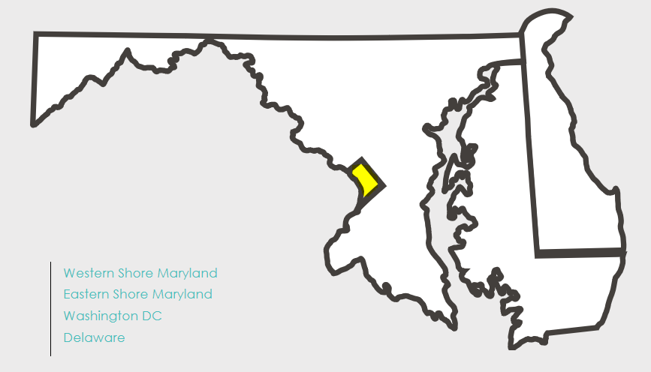
District of Columbia

Next, enter the ticket number and click on SEARCH. If you do not know the ticket number, you may search for the number based on date range, county/DC quadrant and other ticket criteria OR by drawing a polygon of the search area using the map (scroll down to see the map).
Once your ticket number is displayed and you have verified it is the correct location, scroll down the section, MEMBERS NOTIFIED. If the ticket is valid, a Discrepancy button will appear next to any district code for a mark or clear status. A Dispute button will appear only for a code 5 status, Not Complete/In Progress: Locator has spoken to excavator and they have agreed to this message.
See below example of the Discrepancy display.
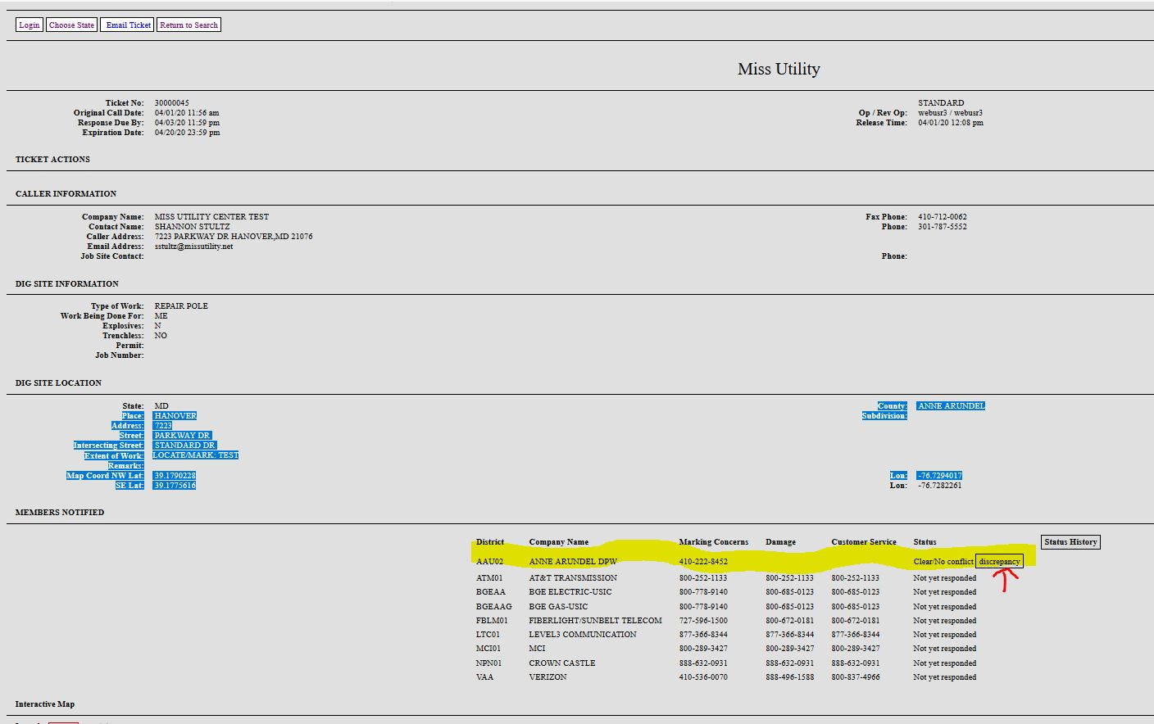
Once the Discrepancy box is clicked on, a pop-up window will appear asking for an email address. Enter your email address and click OK or Cancel if the entry was a mistake.
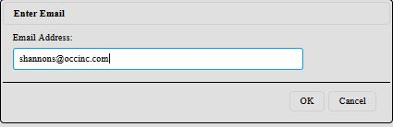
You will receive a message that the email has been queued for delivery.
Next, you will receive an email - Report a ticket discrepancy – providing the ticket number.
This email will have a link to - Finalize the Reporting Of A Ticket Discrepancy.
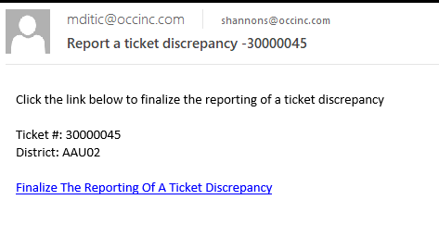
Next, click on the link and you will be taken to the ‘Dispute/Discrepancy’ Issue page, (see below). At this point you can enter comments and attach files (i.e. pictures, drawings, etc.).
When finished, click the “Complete Dispute/Discrepancy” button.
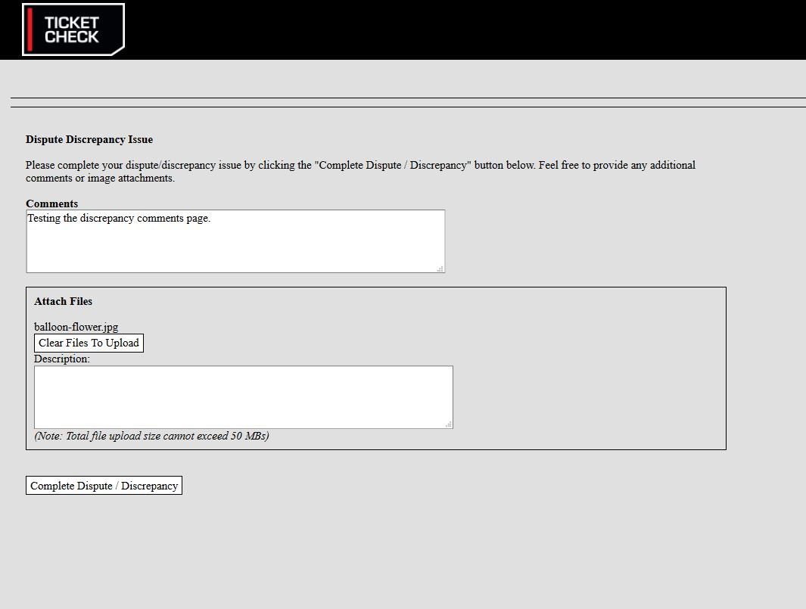
This process will place a Discrepancy (or Dispute) status on Search & Status and Ticket Check, then send a Discrepancy (or Dispute) ticket to the district member/locator. At this point, the Ticket Check code will be UNLOCKED and ready to process the subsequent Ticket Check code for the Discrepancy/Dispute notice.
The excavator’s Discrepancy/Dispute notes will be displayed on the districts transmitted ticket copy (see below ticket example). If an attachment was placed, the attachment link will be appended in the Extent of Work ticket field.
NOTE: The above information is only displayed on the Discrepancy/Dispute transmitted district copy. If the ticket is updated, the Discrepancy attachment does not move forward with the new Update ticket number.
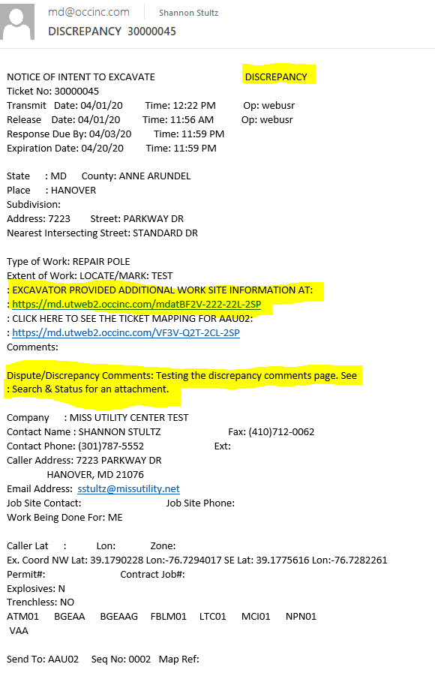
Search & Status will provide the excavator notes in the ‘MEMBERS NOTIFIED - Status’ section of the ticket for the affected district code with a status of DISCREPANCY. Excavator attachments will be displayed in View Attachments (see below example).
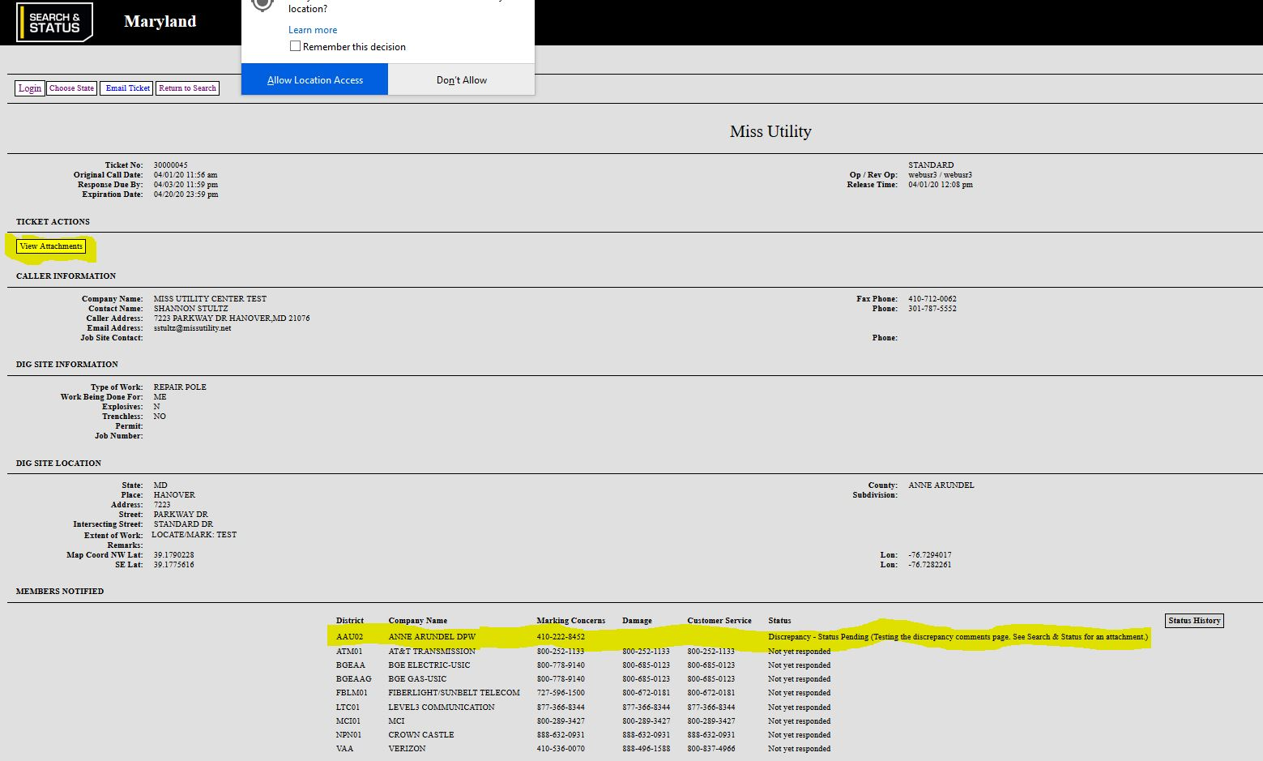

The affected district locator will have two (2) full days to re-status the ticket after their investigation and possible marking.
The locator’s subsequent Ticket Check code/status can be viewed on Search & Status and Ticket Check.
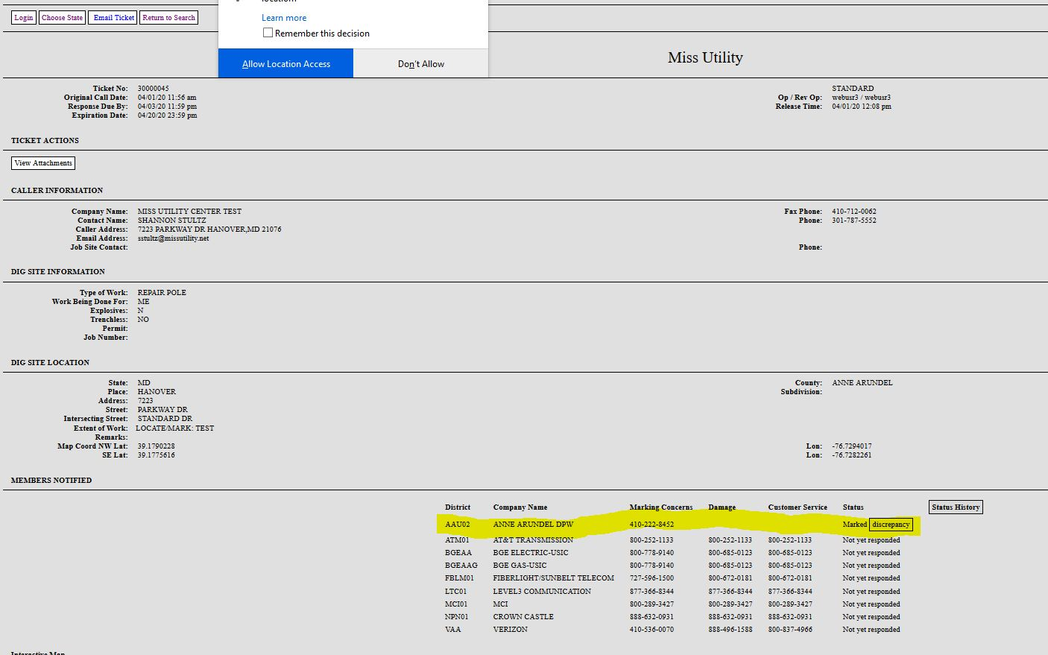
This Ticket Check Discrepancy/Dispute process can be repeated until the ticket expires.
The full status history can be viewed by clicking the “Status History” Button.
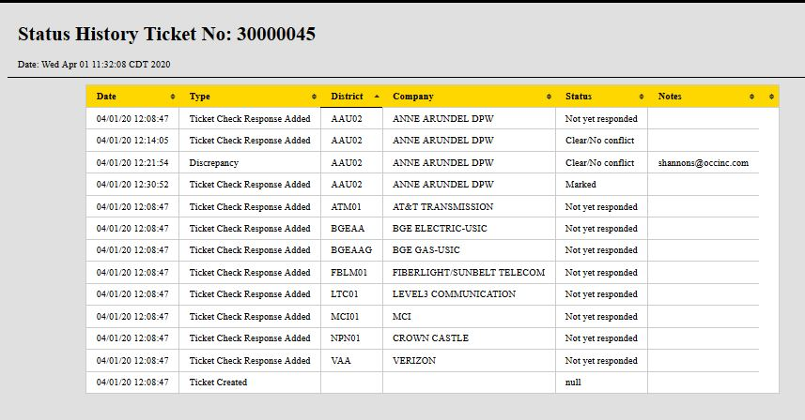

We hope this information has been helpful. If you have any questions, please contact our Help Desk at 410-72-12-0056.

